Reading an excel file using Python
Command to install xlrd module :
pip install xlrd

import xlrd
# To open Workbook
wb = xlrd.open_workbook(work book location)
sheet = wb.sheet_by_index(0)
sheet.cell_value(0, 0) ------extract cell value

# Extracting number of rows
print(sheet.nrows)

# Extracting number of columns
print(sheet.ncols)

another way is

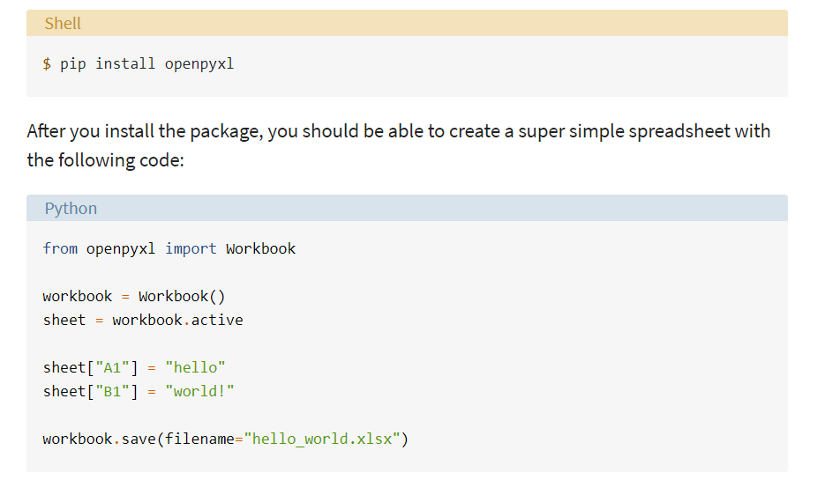

Retrieve the value from excel file
>>> from openpyxl import load_workbook
>>> workbook = load_workbook(filename="sample.xlsx")
>>> workbook.sheetnames
['Sheet 1']

>>> sheet = workbook.active

>> sheet["A1"]
<Cell 'Sheet 1'.A1>

>>> sheet["A1"].value
'marketplace'

>>> sheet["F10"].value
"G-Shock Men's Grey Sport Watch"

Pandas methods to handles different file types

We can read or write data frame from/to any of the below file
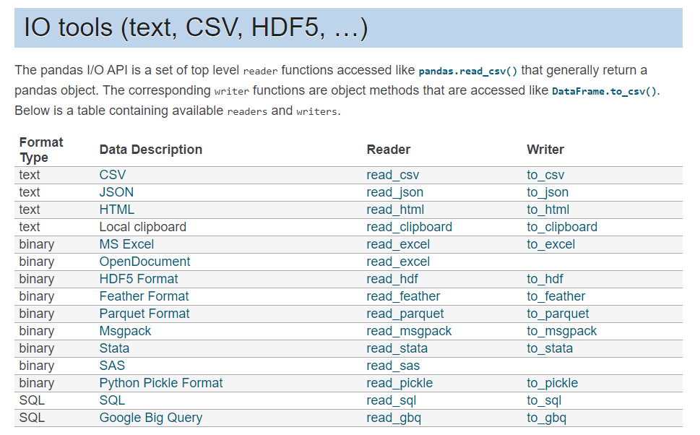

Read SQL Database

import sqlalchemy
conn_str = (
r'DRIVER={SQL Server};'
r'SERVER=IN2NPDVDCOM01;'
r'UID=sa;'
r'PWD=Ate@m2013;'
r'DATABASE=EP20132X;'
r'Trusted_Connection=no;'
)
learn_df = pd.read_sql("select * from PREDICTIONS", pyodbc.connect(conn_str))
pyodbc.Connection.close
learn_df.head(10)

with sqlite3
import sqlite3
connection = sqlite3.connect("company.db")

cursor = connection.cursor()

# delete
#cursor.execute("""DROP TABLE employee;""")

sql_command = """
CREATE TABLE employee (
staff_number INTEGER PRIMARY KEY,
fname VARCHAR(20),
lname VARCHAR(30),
gender CHAR(1),
joining DATE,
birth_date DATE);"""

cursor.execute(sql_command)

sql_command = """INSERT INTO employee (staff_number, fname, lname, gender, birth_date)
VALUES (NULL, "William", "Shakespeare", "m", "1961-10-25");"""
cursor.execute(sql_command)

sql_command = """INSERT INTO employee (staff_number, fname, lname, gender, birth_date)
VALUES (NULL, "Frank", "Schiller", "m", "1955-08-17");"""
cursor.execute(sql_command)

# never forget this, if you want the changes to be saved:
connection.commit()

connection.close()

we can use pyodbc as well
